Digital Communications Systems Lab Exercise 2 Report

By

Somtochukwu Zikora & Saaket Timsina

# Purpose of the Lab

Inter-symbol interference is the interference between the outputs of adjacent symbols (pulses) over the transmission channel. This is because every channel has some limitations when the input has changed. The equalizer can be used to remove the effect by cancelling out the response of the channel at certain sample points.

During this lab, we observed inter-symbol interference in a transmission line, and attempted to cancel it out using an equalization filter. To achieve this, we transmitted a digital bit stream over a channel while using a low pass filter and other methods to eliminate the inter-symbol interference. We were trying to obtain the appropriate eye-pattern by manipulating the filter.

The hardware experiments were done using a series of low-pass RC filters to implement the channel model, an 8-bit word generator delivering rectangular pulses at the input and with a clock of frequency 64kHz.

# Investigation of the distortion properties of transmission lines

The blocks of the block diagram most relevant to the experiment are: Format, Source Encode, Channel Encode, Channel Decode, Source Decode and Format.

## Low-pass channel Properties

The goal here is to approximate the behaviour or frequency response of a transmission line. In this case, the presented model is a second-order low pass filter represented by the impedances of cascaded RC low-pass filters.

1. The derivation for the transfer function for the current model is as follows:

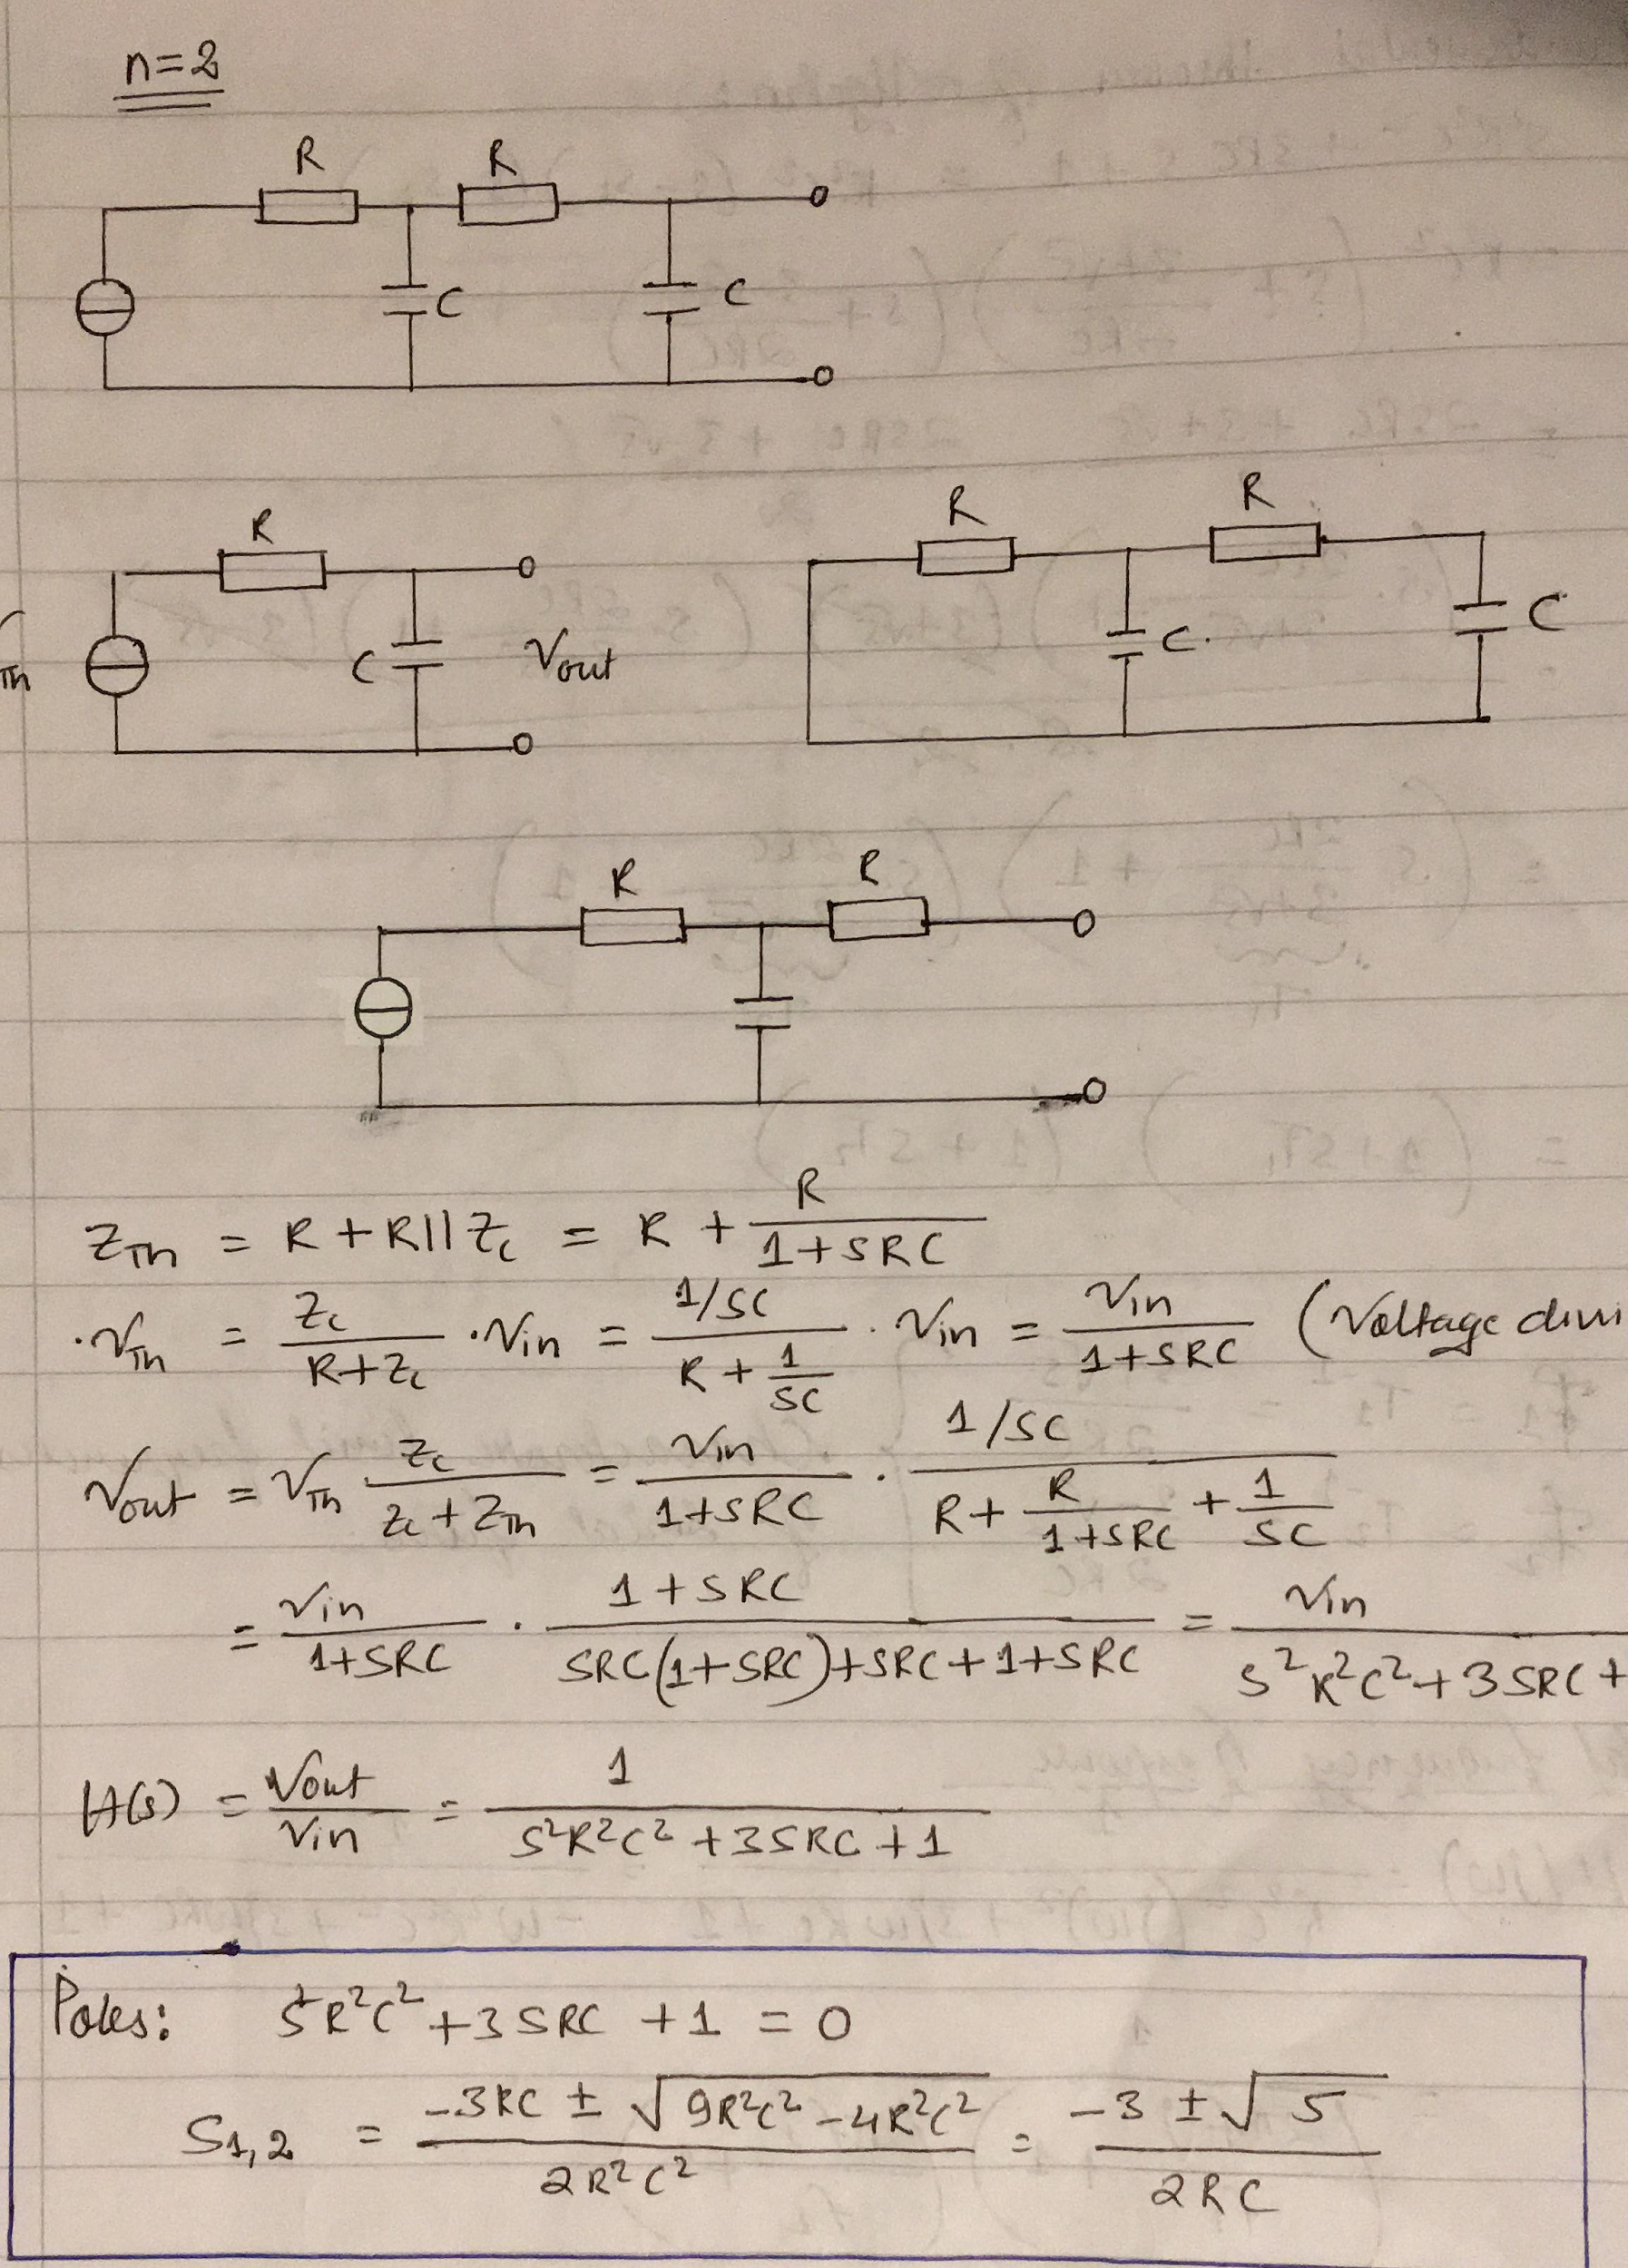

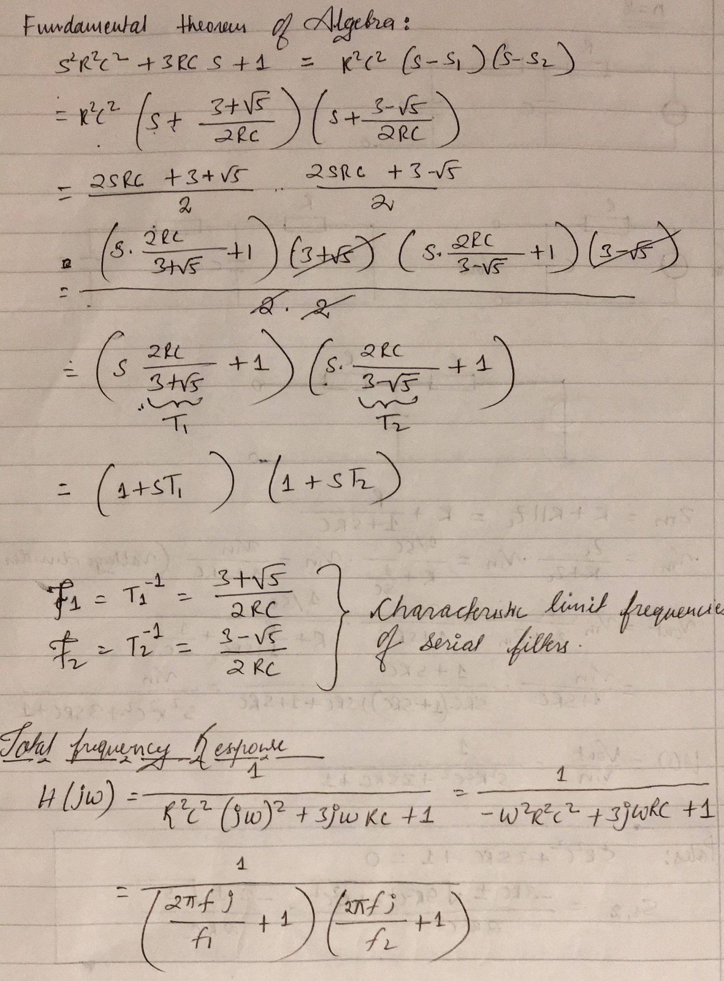

Transfer function and total frequency response when n=2

1.1.b Measure the amplitude response of two different channel settings: For this experiment, the channel model is subjected to a frequency sweep using the Network Analyzer to demonstrate its low-pass behavior (amplitude response for n = 2 and n = 5).

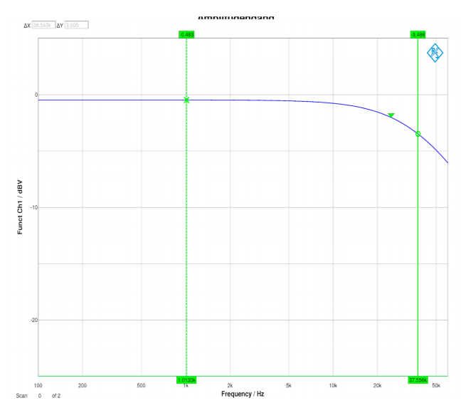

n to the order of 2, cutoff frequency ≅ 37.5kHz

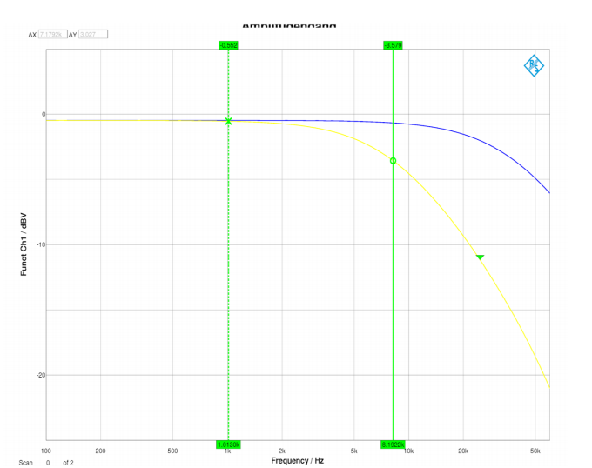

n to the order of 2, cutoff frequency ≅ 8kHz

1.2.a Channel response to input rect(t/T0) pulse of width T0=1/f0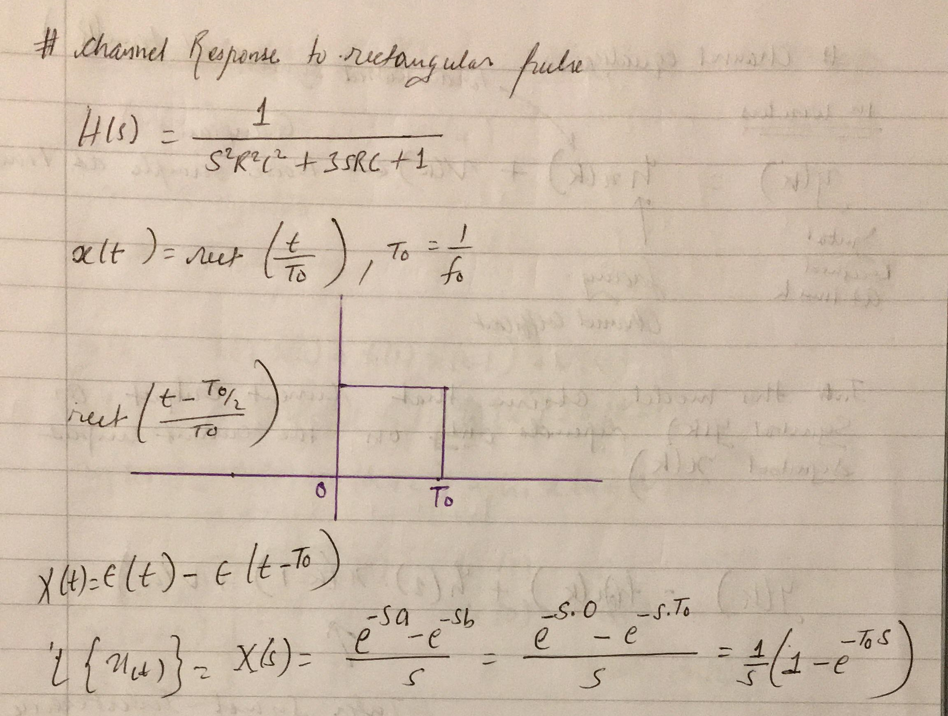

pre-calculation

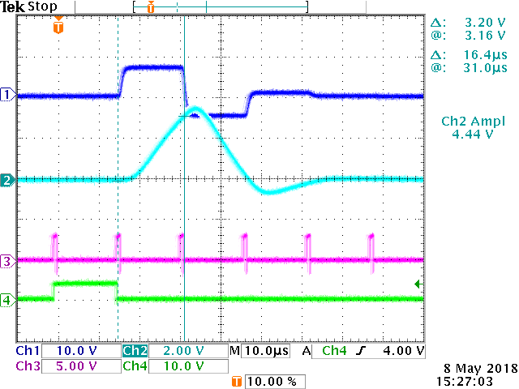

Adjusting all coefficients an

1.3. Measure the response of the channel model box when the input is a random bit sequence generated by the pseudo-noise generator (PNG). Show the corresponding eye-diagrams and use two different settings using n = 2 and n = 5 RC elements.

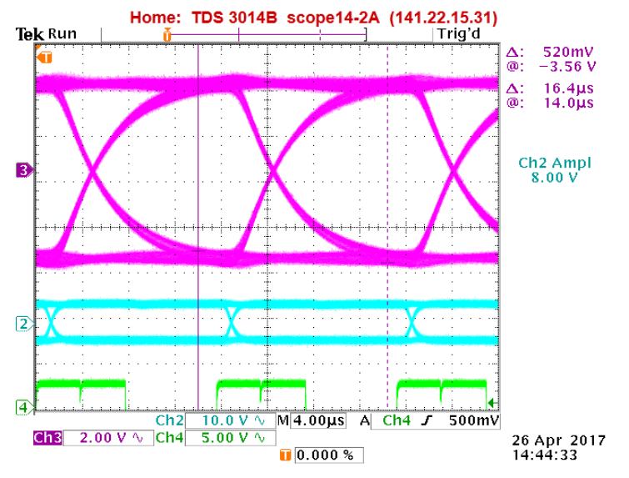

Eye pattern for n=2 and PNG

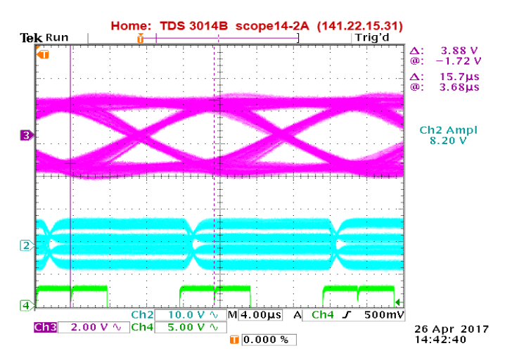

Eye pattern for n=5 and PNG

# 2. Dimensioning of an FIR equalization filter and analysis of the resulting properties

Equalization (with response hFK(t)) aims at achieving samples of value zero for the effective pulse response hg(t)= hFK(t)*hCH(t) (*=convolution) at all other instances outside of the main sample time ts, thus compensating for the ISI caused by channel pulse response in time domain. A Zero at hg(ts=2T0) can be realized by scaling the (delayed) eq-filter pulse response hFK(ts-T0) at time 2T0 with a factor a1 and subtracting the whole function from the channel pulse response: a0∙hFK(t). The figure below illustrates this principle using a simplified pulse response hFK(t). The symbol itself is sampled at time ts=T0. The next Zero must be realized at 2T0 after the main sampling instance, i.e. at ts=3T0 in the figure. Again, this is done by scaling hFK(t-2T0) with a suitable factor a2 before the superposition on top of hg1(t).

|  |  |  |  |
| --- | --- | --- | --- |
| N = 2 |  | N = 5 |  |
| H0 | 3.8V | H0 | 1.7V |
| H1 | 110mV | H1 | 1.2V |
| H2 | 2mV | H2 | 540mV |
| H3 | 1mV | H3 | 240mV |
| H4 | 0 | H4 | 100mV |

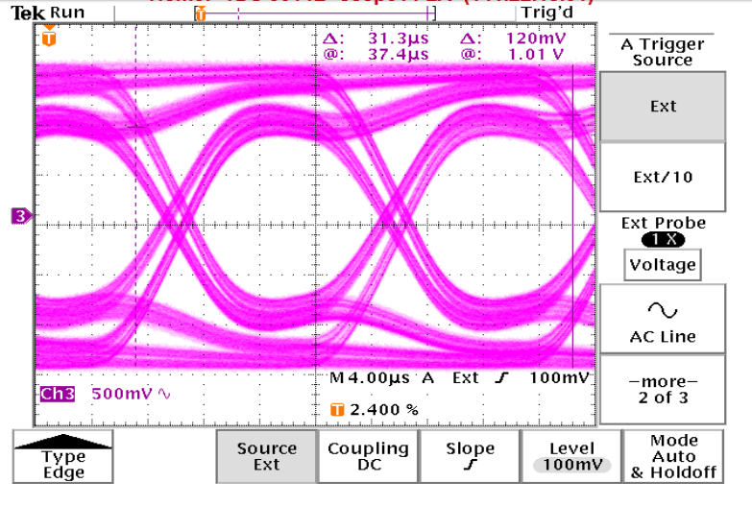

Eye Pattern Diagram

# 3.1 Parametrizing equalizer

We set values of word generator to 1000.0000.0000.0000, f0 = 64 kHz and order of channel model box n= 5.

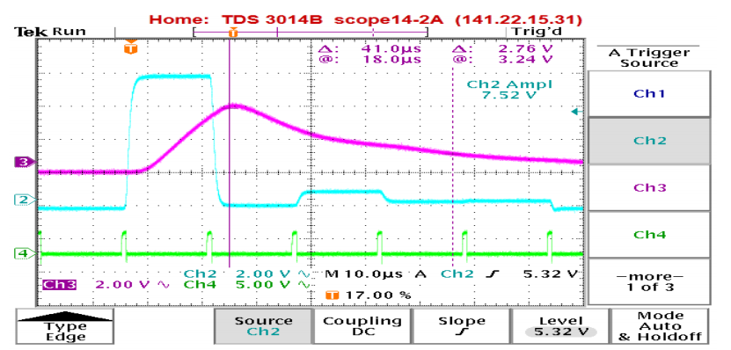

Pulse response when n = 5

To obtain the eye pattern, we must adjust the coefficients by:

a0: zero level of pulse up to maximum level.

a1: maximum level of pulse up to 1 clock, measure range.

an:maximum level of pulse up to n clock, measure range.

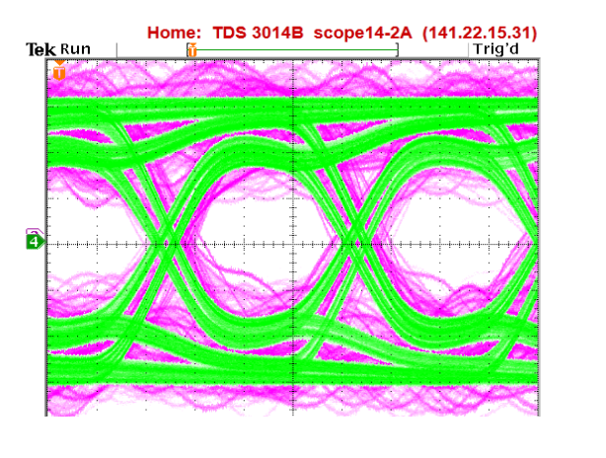

Eye-pattern with noise using -10dB

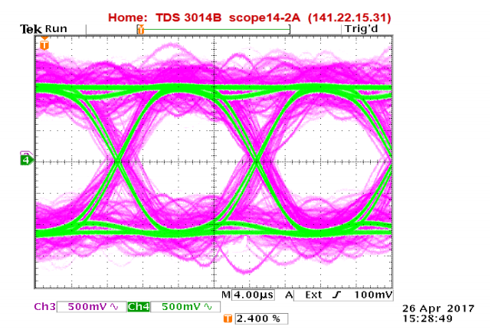

Eye-pattern with noise using -20dB

We tested the edge cases of power level: -10dB and -20dB.

# 4. Manual adjustment of the equalization filter.

We set values of word generator to 1000.0000.0000.0000, f0 = 64 kHz and order of channel model box n= 8.

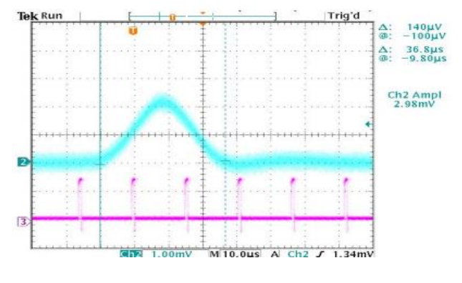

Pulse response on the scope

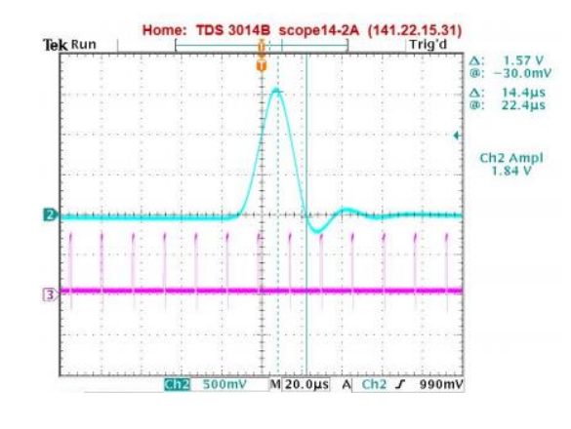

Manually adjusting the coefficient

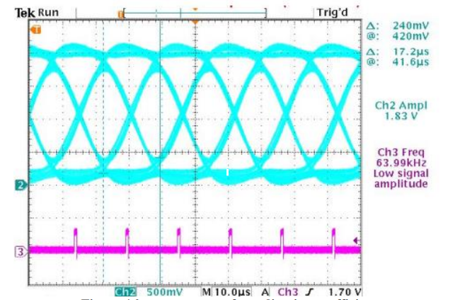

Eye pattern after adjusting coeffiecient